

PROPOSAL FOR AN AUTONOMOUS MAP MAKING ROBOT

**Group 2F:**

Sashank Bandemegala

Nicholas DiPaolo

Adam O’Reilly

Chantel Lepage

Luwan Wang

Aaron Chiu



January 29, 2018

Dr. Alan Steele, Dr. Hicham Chaoui

CARLETON UNIVERSITY - DEPARTMENT OF ELECTRONICS

Table of Contents

1.0 Introduction 2

2.0 Background Information on Autonomous Robots 2

3.0 Project Description 3

3.1 Parts 3

3.1.1 Ultrasonic Sensor 4

3.1.2 Camera Module 4

3.1.3 Power Supply 4

3.1.4 Motor Driver 4

3.1.5 Body 5

3.1.6 Arduino Microcontroller 5

3.2 Project Schematic 5

3.3 Design Approach 6

4.0 Project Management 7

4.1 Roles and Responsibilities 7

4.2 Budget 7

4.3 Deliverables 8

5.0 Conclusion 9

# Introduction

This proposal document is a requirement of the course ELEC 3907. The purpose of this group produced document is to obtain the approval of the projects area of interest, team membership, parts procurement, and the construction of the project. This proposal will include a list of design goals, a chart of the project elements and specifications, a chart of the timeline of the project and a breakdown of the roles and responsibilities amongst the group. A project schedule will be included to show how the project deliverables will be planned out and the time being spent on each deliverable.

# Background Information on Autonomous Robots

This project will be based on an autonomous robot and implementing various sensors and modules. A microcontroller is the main component that controls the various parts individually. The microcontroller follows commands that have been inputted through coding software on a computer. Since the robot has multiple goals, they must have different components to complete each of its goals. Various sensors could be used to achieve autonomous movement of robots such as ultrasonic sensors, Radar sensors or camera sensors. They all have a similar process in which the module sends out a pulse of waves and measures the reflection off an object. The information received from the sensors could be analyzed by software to provide the robot with its next move. The movement of the robot involves 3 main components, an h-bridge to allow for forward and backward movement, motors to convert electrical current into mechanical torque, and wheels to use the torque and move the robot. Together, the components work together with the software for an autonomous robot.

The project that the team has come up, with was an autonomous robot that uses the method above but also include the ability to create a 2-dimensional map of the surroundings and include a live feed of what the robot sees. This would all be done autonomously without the need for a human to control where the robot goes. The map making process would be done through software implementation reading the information provided by the ultrasonic sensor through the Arduino microcontroller.

# Project Description

This project will rely on the fact that a microcontroller controls all the processes of the robot. Using various sensors and modules coinciding with software programming, the autonomous robot will be able to carry out its various duties. The robot will need to detect and avoid obstacles with the use of ultrasonic sensors. These sensors will be connected to an Arduino which will control DC motors that are directly connected to wheels.

## Parts

The project requires various parts and each of them have a very specific role. In order to build a robot that is able to move, motor drivers and wheels are required. Ultrasonic sensors are being used for the purpose of moving autonomously as well as creating a 2D map. To achieve a live feed of what the robot sees, a camera module is being used to broadcast the video feed on to an external device through RF capabilities. A power supply is required in order to power the main components as well as the motor drivers. All together, an Arduino microcontroller is being used to control all the individual parts and the amount of each parts being used are shown in Table 3.1 below.

|  |  |
| --- | --- |
| **Required Parts** | **Amount** |
| Wheels | 2 |
| Ultrasonic Sensors | 4 |
| Motors | 2 |
| Prototype Board | 2 |
| Arduino Nano | 1 |
| DC Motor Plug | 1 |
| Power supply | 1 |

Table 3.1: Required Parts and Their Amount

### Ultrasonic Sensor

An ultrasonic sensor is a tool used to measure the distance from its current location to an object that is in front of it, using an ultrasonic wave. An ultrasonic wave is a sound wave that is undetectable to the human ear but could be processed with a specific receiver. Since the sensor is using a sound wave as opposed to a light wave, the senor would still be able to work as normal regardless of the lighting conditions.

The sensor is able to do this by transmitting and receiving an ultrasonic wave, it transmits a wave and waits for its response in the receiver. By tracking the time between the wave leaving the sensor and gets back to the sensor, it is able to determine the distance of the object from its current position.

These sensors will be a big part of the project as they will be used to make the robot autonomous as well as to generate a 2D map. For the movement, information can be taken from the sensor and then using the microcontroller, when the sensor detects a distance that is too close to an object the robot will turn a different direction. The map can be generated by using the information from the sensors, every point that is reflected back into the sensor would be stored and then simulated on an external device to create a map.

### Camera Module

A camera will be placed on the robot to allow the user to receive a live video feed of the position and whereabouts of the robot. Since the map that is being produced is only 2D this will allow to see if there are any overhanging obstructions that would not be seen with the use of the map alone.

### Power Supply

The main source of power the robot will be using is a 6V 3000mah battery pack. This will be used to supply power for both the Arduino and the two motors for the wheels. The battery pack will be connected in parallel with both a LM317 voltage regulator (for Arduino) and an h-bridge (for wheel motors) as displayed in Figure 3.1

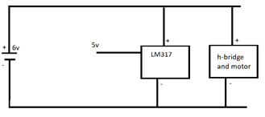

Figure 3.1: Voltage regulator and h-bridge circuit

The Arduino only requires an input voltage of 5V and that is why the voltage regulator is being used, it will take the voltage down from 6V to 5V so it can be fed into the Arduino. The h-bridge, is being used to enable the two controlling wheels to be able to turn both forwards or backwards, it will be drawing in the complete 6V as the motors require 6V to run.

### Motor Driver

A DC motor plug is used to control the movement of the robot. A DC motor plug is a very simple way to control a DC motor, it consists of 2 h-bridges allowing us to control 2 small DC motors at the same time [1].

The DC motor plug is intended to drive a single stepper motor, but also works for driving 2 small DC motors, going forward and backwards. The plug includes 12 male pin to be able to connect to the Arduino, and 12 female pins to connect to the motors. The female pins are split into 2 with 6 pins being for one DC motor and the other 6 being for the other motor [1].

The DC motor plug is being used instead of building an h-bridge from scratch, mainly because of power consumption and size. The DC motor plug is very small and lightweight, allowing for more room on the car and due to its light weight, the car will require less force to move. Having the ability to control each motor will allow for the car to turn on a dime, making it easier to control and maneuver obstetrics.

### Body

The body will be measured, drawn and printed using a 3D printer. The chassis will be built into the body. The body will be made out of plastic which has been created through AutoCAD after precise measurements of the wheels, motors and sensors. The motors will be placed in the front of the body and an ultrasonic sensor will be placed on each side of the body. The center of the chassis will hold the electronics. Figure 3.2 below shows the underbody of the robots body. The electronic components will be underneath and hidden from the eye.

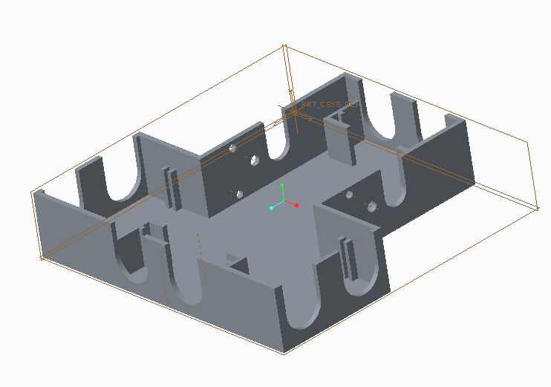

Figure 3.2: CAD Draft of Robot Body

### Arduino Microcontroller

The microcontroller that was chosen for this robot was the Arduino Nano. The reason for not choosing the JeeNode was due to the lack of pins that the JeeNode had. The Nano about 20 usable input pins that would be available to use. The Arduino will be what is used to upload the code onto and will control all the parts of the robot. The Arduino will oversee controlling the sensors, h-bridge, motors, and camera modules.

For the Arduino to control the sensors the programming needed for this will include taking in the data that the sensor is receiving and converting it into a 2D map, and having a code that will read the input values that is obtained from the sensor and have the robot act accordingly depending on the distance to the next object. For example, if the robot is approaching a wall then the Arduino will determine whether the robot needs to turn.

The Arduino will also control the h-bridge and the motors. The h-bridge will allow for the Arduino to either have the motors rotating forwards or backwards. Having the motors able to turn in reverse allows for the robot to turn left and right. If we wish to turn left the Arduino would tell the left motor to spin in reverse and the right motor to spin forwards and vice versa for a right turn. The camera module will be connected to the Arduino so that it can relay a live video feed to the user.

## Project Schematic

The robot will have three wheels, two rubber wheels and one small support wheel. In order to turn the vehicle, one motor controls the car to roll forward and the other to roll backwards. It is easier for the car to turn with three wheels than four wheels, therefore three wheels are chosen for the design. There will be four ultrasonic sensors in each side of the car. Those sensors will measure the distance from the car to its surrounding obstacles and send the data to the microcontroller on the middle. Camera will be added to the car to send a real time video to another device for a user friendly purpose. When put together, it will look like Figure 3.3 below.

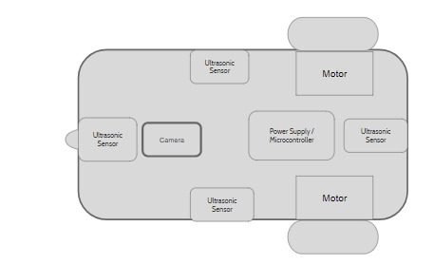

Figure 3.3: Overall Schematic of the Robot

## Design Approach

The correct connection of each component is what makes the robot function properly and achieve all its goals. The power supply is the main driver of power for this portable device. It directly connects to the Arduino as well as the DC motor plug which drives the motors. The Arduino passes on the power to the other components such as the camera module and ultrasonic sensors. The Arduino will control the camera module and sensors in order to transmit orders and acquire results to be used for mapping and navigation purposes. The high level design of the robot is shown in Figure 3.4 below.

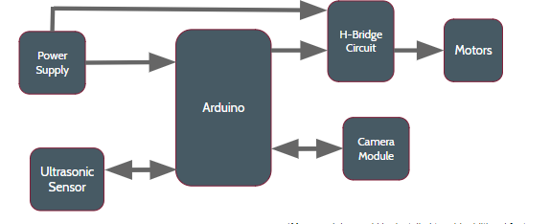

Figure 3.4: High Level Design of the Robot

# Project Management

The 6 member group was created randomly by the professor counting numbers from 1 through 8. Although the groups were created randomly, they team that was created work nice together. The budget for the project, timeline of the project deliverables, as well as the roles and responsibilities of each individual are shown below.

## Roles and Responsibilities

With the group having 6 team members and a lot of work needed that is to be done, the group has been split up evenly with everyone having primary and secondary roles. The primary role is the main interest of the individual and what the team member feels most comfortable with. The secondary role was introduced to bring new ideas in and help another team member brainstorm or build the components. The breakdown of the team members roles and responsibilities are shown in Table 4.5 below.

|  |  |  |  |
| --- | --- | --- | --- |
| **Name** | **Primary** | **Secondary** | **Specific Topic** |
| Sashank Bandemegala | Hardware | N/A | Camera Module |
| Nicholas DiPaolo | Hardware | Software | Motor Drivers |
| Adam O’Reilly | Software | Hardware | Motor Drivers |
| Chantel Lepage | Software | Hardware | Autonomous driving |
| Luwan Wang | Software | N/A | 2D Map Making |
| Aaron Chiu | Hardware | Software | Autonomous driving |

Table 4.5: Breakdown of Roles and Responsibilities

## Budget

The budget for this project has been set to $100 including tax and shipping costs. This budget has been established by the professors of the course. The parts are being ordered from various websites that were suggested by the parts procurement teaching assistant. Although the budget is $100, some parts were found within the lab which were available for the group to use. The parts that were found in the lab are not being included in the budget but they are included within the costs shown in Table 4.6 below.

|  |  |
| --- | --- |
| **Required Parts** | **Cost** |
| Rubber Wheels | 2 @ $2.20 each  = $5.20 |
| Small Wheel | $0  3D printed |
| Ultrasonic Sensors | 4 @ $4.39  = $17.96 |
| Motors | 2 @ $3.50  = $7.00 |
| Prototype Board | 2 @ $1.92 each =  $3.84 |
| Arduino Nano | $9.99 |
| Dual H bridge | $5.00 |
| Power supply | $34.42 |
| **Total** | **$83.4** |

Table 4.6: Parts and Their Costs

## Deliverables

With a big project that is being produced, comes many deliverables and goals that must be reached within a certain amount of time. The beginning of the project is to acquire and assemble the hardware components of the robot and tests its movements using physical components. The next part of the project would be installing the sensors and programming and testing for autonomous movement of the robot. Once the movement has been taken care of, the sensors information must be recorded in order to create a 2D map of what the robot sees. The last part of the project includes adding the camera to implement a live feed on an external device as well as testing thoroughly to ensure everything works. The expected timeline for the project is shown in Table 4.7 below.

|  |  |  |  |
| --- | --- | --- | --- |
| **Task Name** | **Start** | **End** | **Duration (days)** |
| Ordering of main parts | 2018-01-22 | 2018-01-29 | 7 |
| Overall high-level design | 2018-01-29 | 2018-02-05 | 7 |
| Assembling main robot parts | 2018-02-05 | 2018-02-12 | 7 |
| Testing for basic movement | 2018-02-12 | 2018-02-19 | 7 |
| Assembling ultrasonic sensors | 2018-02-19 | 2018-02-26 | 7 |
| Programing and testing for autonomous movement | 2018-02-26 | 2018-03-05 | 7 |
| Software implementation of making a 2D map | 2018-02-26 | 2018-03-12 | 14 |
| Test of mapping and adding camera module | 2018-03-12 | 2018-03-19 | 7 |
| Programing and testing of sending real time video | 2018-03-19 | 2018-03-26 | 7 |
| Final test and adjustment | 2018-03-26 | 2018-04-11 | 16 |

Table 4.7: Deliverables Chart with Expected Duration

The timeline for the project is shown through the Gantt chart in Figure 4.8 below.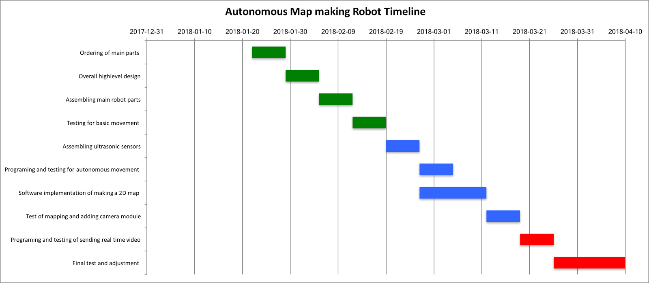

Figure 4.8: Gantt chart of Project Timeline

# Conclusion

The purpose of this group proposal is to obtain the approval of the projects area of interest, parts procurement, design and the construction of the project. The proposal outlines how all the project deliverables will be organized with all the team members as well as everyone's roles and responsibilities. This project has many uses other than the one it was built for. Apart from creating a map and having a live camera feed of what the robot sees, it will have the ability to add additional modules on it for further features on the same robot.